Registration Process
Step1: Create an Account
The url address should be: https://thechronicleng.com.ng/createa-account

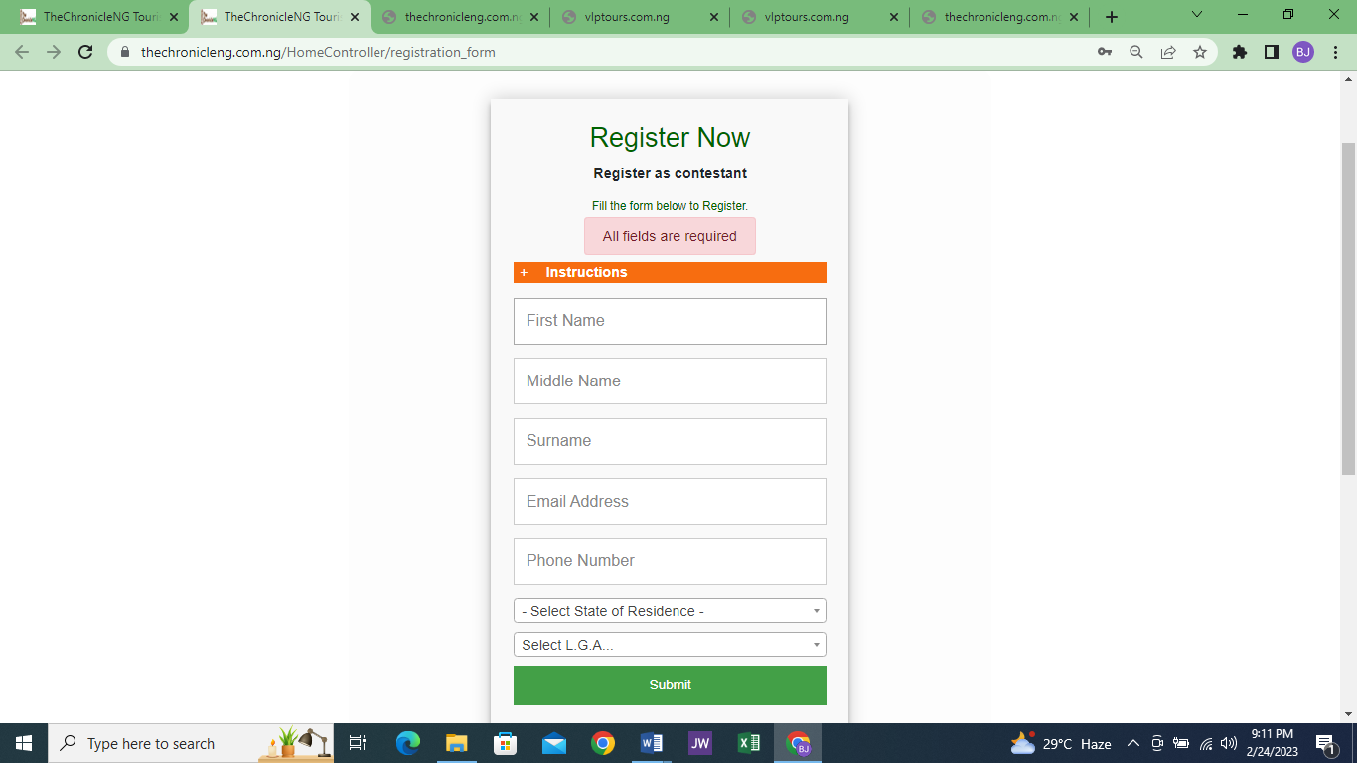

Conditional Statement
By registering for TheChronicleNG Tourism Reality Show you agree that as part of the conditions to qualify for selection, you must get at least one person to register for the Follow tour package, who will accompany you, as a fan, to the communities you will be assigned to research. The more fans you get to register the better your chances of been selected. Your fan(s) should register, using the reference number that will be generated for you after registration, for easy tracking.

I Agree

Step 1 of 9: (Personal Details)
The url address should be: https://thechronicleng.com.ng/Contestant/person1

- Surname: (preloaded upon login)
- First Name: (preloaded upon login)
- Middle Name: (preloaded upon login)
- Email: (preloaded upon login)
- Phone Number: (preloaded upon login)
- Alternate Phone:
- Full Address:
- Gender: (Male, Female)
- Date of Birth: (check for eliibiity)
- Age (in Years): (calculated and shown based on supplied DofB)
- Marital Status: (Single, Married, Divorced, Widowed)

Save Continue

Step 2 of 9: (Personal Details)
The url address should be: https://thechronicleng.com.ng/Contestant/person12
- Any Health or Physical Challenge: (Yes, No)
- IfYes, Give Details:
- Languages Spoken:
- Hobbies:
- Display Photo: (must be recently taken assport photo not more than 100kb size)
- Choose photo
Note: As a pre condition for selection, you’re to write and essay on a topic that the system would generate for you. You woud be required to defend the essay during audition

I Agree

Back Save Continue

Step 3 of 9: (Educational Background)
Url address should be: https://thechronicleng.com.ng/Contestant/educ
- Educational Status: (Graduate, Undergraduate, Post Graduate)
- Qualification: (Diploma, National Diploma, HND, B.Sc., P.Hd., Other)
- Certificate/School ID Card: (Browse to upload) (only pdf allowed not more than 100kb)
- Course Studied:
- Institution Attended
- Are You Comuter Literate: ( Yes, No)

Back Save Continue

Step 4 of 9: (Social Media Page)
Url should be https://thechronicleng.com.ng/user/social_media
- Facebook
- Twitter
- Instagram
- LinkedIn
- YouTube
- Pinterest

Back Save Continue

Step 5 of 9: (Views on Tours)
Url should be https://thechronicleng.com.ng/user/tours_views

Which of these tours would you embark on and with whom, if you have the opportunity
- Community Adventure: (Individual, Romantic, Family)
- Beach Picnic: (Individual, Romantic, Family)
- Tour with Celebrity: (Individual, Romantic, Family)
- Foreign Tour: (Individual, Romantic, Family)

Back Save Continue

Step 6 of 9: (Views on Tourism and Culture)
Url should be https://thechronicleng.com.ng/user/tours_culture
- What do you think about the state of tourism in Nigeria? Is it growing or stagnat? (50 words)
- What are the challenges hindering the development of tourism in Nigeria? (250 words)
- In your opinion, how can domestic tourism be developed in Nigeria? (500 words)
- Explain the problems limiting the development of tourismMention/list ten cultural festivals celebrated in Nigeria in Nigeria (250 words)
- Mention/list ten laces of attraction in Nigeria and then suggest how these can be harness to drive tourists to the places of attractions mentioned. (400 words)

Back Save Continue

Step 7 of 9: (Views on Tourism and Culture)
Url should be https://thechronicleng.com.ng/user/tours_culture2
- Mention/list ten cultural festivals celebrated in Nigeria and the state where each is celebrated (100 words)
- State briefly the role of culture in the development of tourism, as it relates to Nigeria. (200 words)
- What skill(s) and/or abiity do you possess that will make you excel in this competition? (50 words)
- What do you expect to achieve at the end of the reality show? (50 words)

Back Save Continue

Step 8 of 9: (Your Essay)
Url should be https://thechronicleng.com.ng/user/your_essay
Essay Topic: (to be auto generated)

Type your essay online in the textbox below or upload a file, only in .txt file format allowed. Max of 2000 words

Textbox here

Uload prepared Essay document: (Browse to select File)

Back Save Continue

Step 9 of 9: (Your Video)
Url should be https://thechronicleng.com.ng/User/video_submit

At this point the dashboard would be visible but not accessible. When every part has been fully completed and video submitted, then the dashboard would be accessible uon login.
- Upload Video: (browse file)
You are to shoot and submit a video of your Essay’s prologue, along with your reistration form. The video must not exceed 3 minutes in length. Max size: 50MB

Back Submit

Dashboard Content for Registrants
- Dashboard
- Notification
- Update my Profile
- Change Password
- Reference Number
- My Essay Topic
- Invite Friends
- Follow

Dashboard Content for Contestants
- Dashboard
- Notification
- Update My Profile
- Change Password
- Reference Number
- My Essay Topic
- My Followers
- Post
- Invite Friends
- To Follow
- To Connect With Me
- Logout

